Forecasting Food Delivery Order Trends

Introduction and Objective
The main goal of this project is to use time series forecasting methods to forecast volumes of food delivery orders for an online food delivery company. Precise forecasting of order volumes allows for improved operational planning, such as staffing, resource allocation, inventory control, and logistics optimization.

Research Question:
How effectively can time series models such as SARIMA and LSTM predict hourly food order volumes based on historical data?

Problem Statement:
To implement and compare several time series forecasting models:
1. A SARIMA model using trend and weekly seasonality.
2. A Univariate LSTM model forecasting future orders from the last 10 hourly order values.
3. A Multivariate LSTM model forecasts future orders from several exogenous variables (cloud coverage, precipitation, temperature, wind speed) and order history.

Data Collection and Preprocessing

Dataset Description:
- Source: Provided dataset — orders_autumn_2020.csv
- Features:
  - ORDER_ID — unique identifier
  - TIMESTAMP — order placement date and time
  - USER_LAT, USER_LONG — customer’s coordinates
  - VENUE_LAT, VENUE_LONG — restaurant’s coordinates
  - (In extended experiments, simulated external weather features were included: CLOUD_COVERAGE, TEMPERATURE, WIND_SPEED, PRECIPITATION.)
- Time Period: July 1, 2020, to September 30, 2020

For data preparation for time series forecasting, various preprocessing steps were undertaken. Initially, the TIMESTAMP column was converted into Python datetime objects, and other time-based features like date, hour, and weekday were derived to enable temporal analysis. The geographic distance between a customer and the venue corresponding to them was subsequently calculated using the Haversine formula via the geopy library, enabling an extra spatial feature for analysis.
Then, the data was grouped by hour and date to calculate the total orders made in every hour interval. Because there were missing data points in some of the hours during the working period of 4 AM to 10 PM, a special utility function fill_all_hour_data, was employed to complete the missing values by inserting records with zero orders where appropriate so that there was a complete and uniform time series.
For the LSTM models, the data was normalized by Min-Max scaling to enhance training stability and convergence. The preprocessed data was then divided into training and test sets based on an approximate 65-35 ratio. Lastly, time-stepped datasets were constructed to put the data into a form appropriate for sequential modeling: in univariate form, past order volume only was fed in as input, but for multivariate modeling, external features like cloud coverage, rain, temperature, and wind speed were also added on top of historic order data.

Steps:
- Converted TIMESTAMP to datetime, extracted date, hour, and weekday.
- Calculated customer-to-venue distances using Haversine formula via geopy.
- Aggregated order counts by date and hour.
- Filled missing hourly records (for hours 4 AM–10 PM) per day using custom fill_all_hour_data utility.
- Normalized data using Min-Max scaling for LSTM models.
- Split data into training and testing sets using an approximate 65-35 split.
- Created time-stepped datasets for LSTM models:
- Univariate: using only past order counts.
- Multivariate: including weather-related external variables.

Time Series Modeling and Diagnostics
To achieve the project's goal of precisely projecting hourly food delivery order amounts, two modeling methods were applied: a SARIMA model and LSTM-based models (univariate and multivariate). These models played complementary roles in the project — SARIMA gave a solid statistical foundation by detecting temporal patterns like trends and weekly seasonality, while LSTM models used deep learning to capture intricate, non-linear patterns in the order data and enhance forecasting performance, particularly during periods of drastic fluctuation.

SARIMA Model
We have selected the SARIMA (Seasonal Autoregressive Integrated Moving Average) model as it can reflect both non-seasonal (ARIMA) and seasonal elements within the time series data. The model reflects current hourly order amounts and their prior forecast errors in addition to extracting recurring weekly trends — a fundamental feature for food delivery businesses, which generally conform to daily and weekly patterns.

For model selection, the auto_arima function from the pmdarima library was utilized to automatically select the optimal combination of parameters based on Akaike Information Criterion (AIC) scores. The optimal model parameters were set as:

- (p,d,q) = (1,1,1)
- (P,D,Q,s) = (1,1,1,7), where s=7 represents a weekly seasonal cycle.

To confirm the fit of the SARIMA model, a few diagnostic tests were conducted. The residual analysis based on ACF and PACF plots verified that residuals resembled white noise, without any noticeable autocorrelation. A normality test via QQ plot revealed residuals to be near-normal, in favor of a valid model. In general, no autocorrelation was noticed in the residuals, verifying an accurate model fit.

The SARIMA model is used as a baseline statistical model in this project. Its function is mainly to identify the linear and seasonal patterns in the past hourly ordering data and deliver readable forecasts. It provided a basic forecast against which more intricate LSTM-based deep learning models would be compared.

LSTM Models
We have also implemented the LSTM (Long-Short Term Memory) Model, considering the possibility of limitations in statistical models such as SARIMA in identifying non-linear trends and abrupt spikes in demand. LSTM networks are a category of recurrent neural network (RNN) ideally suited for sequential data and time series prediction.

Univariate LSTM
The univariate LSTM model is made to forecast the orders in the following hour as a function of the last 10 hours' order counts. The time series data is converted to a supervised learning form initially utilizing a sliding window method. A single hidden LSTM layer and dense output layer constitute the model structure, which is trained with Mean Squared Error (MSE) loss and Adam optimizer.
During training, training and validation loss curves are graphed over epochs. The loss curves declined continuously without any indication of overfitting, suggesting successful learning of order patterns from past data. Plotted visually, the forecast plots revealed that projected values tracked well with real order quantities, particularly for short-term predictions within the range of 3–5 hours ahead.
The univariate LSTM serves as a deep learning-based forecasting model utilizing sequential dependencies in sequence data. Its function is to experiment whether a pure order-history-based LSTM could surpass standard SARIMA forecasts, particularly in the capture of short-term temporal patterns.

Multivariate LSTM
We have constructed a multivariate LSTM model to improve forecasting accuracy. In addition to utilizing the last 10 hours of order numbers, this model also incorporates multiple external factors — cloud cover, temperature, wind speed, and rain, all of which are known to impact demand for food delivery. The model architecture is based on the univariate LSTM but includes extra input features at every time step.
Training and validation loss curves for the multivariate model showed steady convergence, with minimally lower loss values compared to the univariate model. This improvement is due to the incorporation of external explanatory variables, which provide significant context for predicting demand fluctuations. Plots of forecasts demonstrated that the multivariate LSTM made very accurate predictions, particularly for steep spikes and valleys in order volume, outperforming both SARIMA and the univariate LSTM model.
The multivariate LSTM model serves as the main advanced forecasting model. Its purpose is to determine if it was possible to boost forecast accuracy by using external contextual information, providing more in-depth operational insights on how contextual factors such as weather conditions affect food delivery order volumes. The model displays the best forecasting performance in the project and confirms the value of a multivariate deep learning method.

Collectively, these models give the business a complete forecasting solution, with each model playing a role in comprehending different elements of the data and confirming the effect of different predictive methods on forecast accuracy.

Forecasting and Evaluation

SARIMA Forecast:
A Seasonal Autoregressive Integrated Moving Average (SARIMA) model is employed to forecast the number of orders for the next 30 days based on historical hourly data.
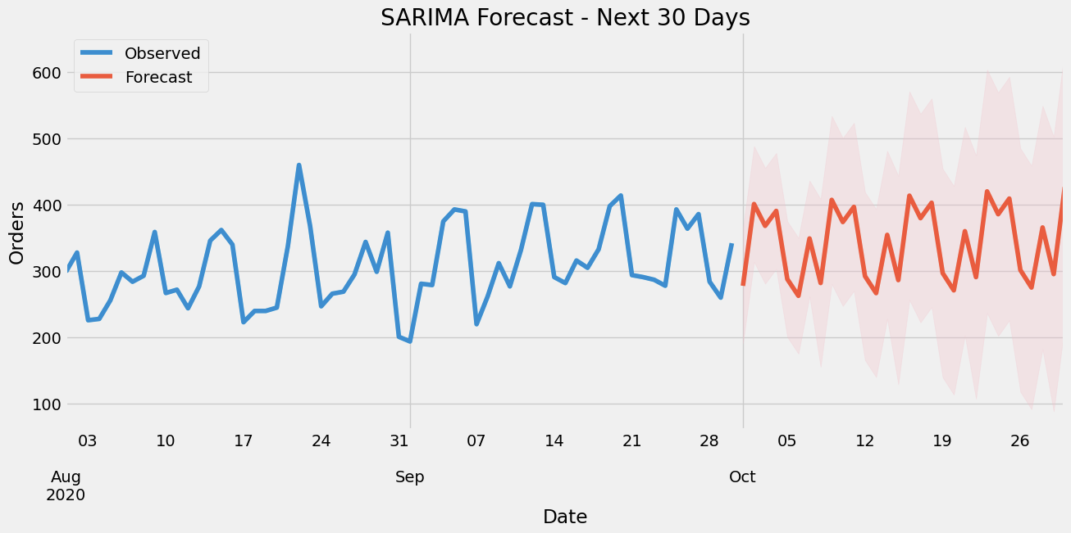

- Forecast Horizon: 30 days (14-step ahead hourly forecasts internally aggregated)
- Visualization: The graph above displays the observed values (in blue) and the forecasted values (in red) with a 95% confidence interval (shaded region).
- Performance Metric Used: Root Mean Square Error (RMSE)

The SARIMA model was able to identify the underlying trend and seasonality of the data properly. This is observable based on how the forecasted values trace the pattern of the observed data throughout the training interval and achieve a similar periodic behavior within the forecasted interval. The model was able to produce a consistent and steady pattern of forecasts for the 30-day horizon, consistent with observed operational trends in the historical data. The addition of confidence intervals provides richness to the prediction by showing the anticipated range of variation around each point of prediction, which increases naturally with time as uncertainty in longer-term predictions grows.
Although the model was generally good, there were occasional discrepancies between the actual and predicted values, especially when volatility was high. This is to be expected in univariate time series models such as SARIMA, which are based on historical data points alone and cannot account for external influences such as promotions, holidays, or unexpected operational changes that may affect order volumes. Despite these small oscillations, the capacity of the model to follow the overall trend and seasonality trend suggests that it is suitable for short to medium-term order quantity forecasting.
The application of RMSE as a measure of evaluation also validated the performance of the model, with smaller RMSE denoting a negligible average forecast error. Overall, the SARIMA model yielded accurate and consistent short-term forecasts for order volumes, both capturing seasonal and trend patterns within the time series. Its performance indicates that it can be an effective tool in operational planning, inventory control, and resource planning in future business operations.

LSTM Forecast:
Hourly predictions were made using univariate and multivariate LSTM models. The models were trained and tested on past order data, and their performance was compared against actual observed values. Root Mean Squared Error (RMSE) and Mean Absolute Error (MAE) metrics were utilized to measure forecast accuracy.

Univariate LSTM
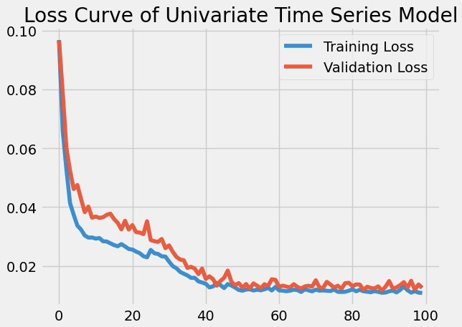

The univariate LSTM model using only the past order values worked effectively for short-term forecasts, especially in the next 4–5 hours. This can be seen from the loss curve, wherein the training and validation losses both reduced consistently and eventually plateaued at a low level, showing good learning but no overfitting.

Multivariate LSTM
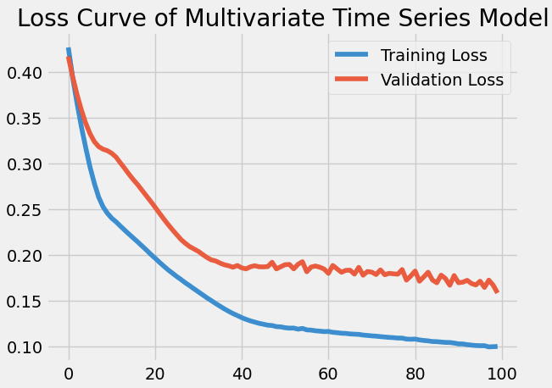

Conversely, the multivariate LSTM model, including extra external features with past order information, exhibited better performance, particularly for instances of sudden spikes and drops in orders. The multivariate loss curve posted a greater initial loss owing to added data complexity but ultimately secured stable convergence, with both training loss and validation loss registering a smooth declining trend. Even though the validation loss was still a bit above the training loss, it demonstrated steady model generalization on unseen data.

Overall, the LSTM-based models effectively captured the temporal patterns within the dataset, with the multivariate approach offering improved accuracy and robustness in forecasting under volatile conditions.

Conclusion

Summary
This research investigated the use of both conventional statistical models and recent deep learning methods for forecasting hourly food order demand. The SARIMA model was found to be effective in modeling the general trend and evident weekly seasonality patterns in the past order data. Its simplicity, interpretability, and ease of parameter adjustment make it a useful choice for setting baseline forecasts, particularly in settings where computational resources or large datasets may be constrained.

The univariate LSTM model, trained to learn sequential dependencies based on past counts of order only, showed excellent short-term forecasting performance. It did exceptionally well within a 4–5 hour ahead horizon. Its performance did degrade, though, in the case of irregular or sudden spikes in demand, which the model could not anticipate because there was no contextual information beyond historical values.

Conversely, the multivariate LSTM model, which included weather conditions and external influencing parameters as well as other related variables along with historical order data, produced the most precise and accurate predictions. It performed better, particularly when demand changes were steep, by efficiently modeling both exogenous variable impacts and temporal relationships. This generated richer operation insights, which showed how weather fluctuations have substantial impacts on customers' ordering patterns and food delivery demand.

Implications
The results of this research underscore the applied significance of forecasting methods for data-driven operational planning in the food delivery sector. Precise demand forecasts enable businesses to pre-emptively schedule delivery personnel according to expected volumes of orders, thereby ensuring prompt service and enhanced customer satisfaction. Likewise, kitchen operations can be dynamically reallocated to manage workload, prevent bottlenecks, and minimize food waste.

In addition, incorporating demand forecasts within marketing and promotional campaign schedules allows for enhanced targeting of offers and ads, optimizing campaign effectiveness during peak-demand times. Having the capacity to forecast weather-adjusted demand patterns also offers a strategic benefit, as it enables planning around resources and operational realignments in anticipation of environmental shifts, avoiding disruptions and lost opportunities.

Limitations
- SARIMA Model:
  - Effective in detecting trends and seasonal patterns.
  - Cannot model complex non-linear relationships.
  - Requires a strong and consistent seasonal structure for reliable forecasts.
  - Less suitable for highly dynamic or irregular demand environments.
- Univariate LSTM Model:
  - Performs well in capturing short-term sequential dependencies.
  - Limited by relying solely on historical order data.
  - Struggles to forecast accurately during volatile or irregular demand conditions.
  - Cannot incorporate external factors influencing demand.
- Multivariate LSTM Model:
  - Delivers superior forecasting accuracy by incorporating external variables.
  - Performance heavily depends on the availability, quality, and timeliness of external data (e.g., weather, promotions).
  - Predictive power diminishes if external data is missing, incomplete, or inaccurate.

Future Improvements
In order to better inform forecasts and robust model development, a number of areas for further improvements have been identified. Firstly, increasing the duration of the dataset by including more months or years of data would enhance the capacity of the model to learn long-run patterns and trends and result in more stable and dependable forecasts.
Secondly, incorporating other contextual data like holiday calendars, regional events, advertising campaigns, and competitor activity can make the multivariate model richer, enabling it to consider a wider set of demand drivers.
Investigating hybrid frameworks that leverage the strengths of each statistical and deep learning method, like blending SARIMA's trend and seasonality estimation with LSTM's non-linear pattern detection, might lead to even more interpretable and accurate forecasting systems.
Lastly, implementing a real-time demand forecasting system through REST API integration would allow operations teams to see the latest predictions in real time, allowing them to make dynamic decisions and respond instantaneously to shifting demand patterns. This would reposition the forecasting system from a periodic reporting capability into a fundamental operational tool for real-time, data-driven business management.

